

The 12th HIT International Summer School on Big Data and Business Analytics (Second Announcement)

July 12–15, 2026

Harbin, China

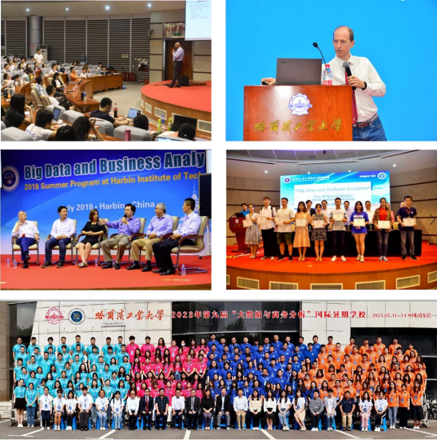

Harbin City Promotional Video
HIT SEM Promotional Video

Program Overview
The School of Economics and Management at Harbin Institute of Technology (HIT) is among the first management schools established in China; its Management Science and Engineering discipline is a national first-level key discipline. Hosted by HIT SEM, the summer school invites distinguished scholars and industry experts in information systems and related fields worldwide to lecture on frontier topics in big data, offering young scholars and doctoral, master’s, and undergraduate students an opportunity to learn from leading researchers and strengthen their research capabilities, while building a platform for exchange and long-term collaboration among scholars, advancing high-quality research.
The summer school will be held at HIT during July 12–15, 2026, with “Big Data,” “Artificial Intelligence,” and related knowledge and practice as the learning focus. The curriculum covers management information systems in the big-data era, artificial intelligence, marketing, and e-health, spanning frontier research topics, methods, and industry developments. The program combines plenary lectures with group discussions, where participants discuss cutting-edge research with internationally renowned scholars.
HIT will provide students who complete the full program with 2-credit certification.

01 Organization
Host: HIT School of Economics and Management

02 Dates and Venue
Dates: July 12–15, 2026
Venue: HIT School of Economics and Management, Harbin

03 Application
Application deadline: June 25, 2026
Official website: http://som.hit.edu.cn/qkhy/sqxx.htm

Lecturers
The summer school has invited outstanding scholars and practitioners from leading universities and industry worldwide in information systems, fintech, and related fields, many of whom serve on the editorial boards of top journals in management science and information systems, with extensive research experience. The lecturers are as follows:
Speaker | Affiliation | Topic
Zhengzui Jiang | Professor, Chinese U of Hong Kong, Shenzhen  Senior Editor of ISR  Former Associate Editor of MISQ | Survival Models and Diffusion Models and Their Applications in Business Research
Xiaole Wu | Professor, Fudan University  Senior Editor of POM | Global Supply Chain Challenges and Research Topics in a Complex Political and Economic Environment
Xianghua Lu | Professor, Fudan University | Variable Measurement and Causal Inference in Behavioral Research
Rajiv Kohli | Chair Professor, William & Mary  Senior Editor of ISR | Healthcare is Everyone’s Business: How Governments, Providers, Insurers, and Patients can prepare for tomorrow’s challenges
Subodha Kumar | Chair Professor, Distinguished Professor of Fox School of Business, Temple University  Co-EIC of POM | to be decided
Bin Gu | Professor and Department Head of Information Systems, Boston University  Senior Editor of ISR | to be decided
Juan Feng | Professor, Tsinghua University  Senior Editor of ISR | Applications of Artificial Intelligence in Enterprises

Participant Information

01 Eligibility
This year’s summer school is open to applicants worldwide, primarily faculty members, young scholars, enrolled students, and industry professionals in management science and engineering, management information systems, marketing, artificial intelligence, and related disciplines. Owing to funding and venue constraints, the organizing committee will make admission decisions based on a comprehensive review of applicants’ academic backgrounds and qualifications.

02 Fees
The summer school charges no registration fee; participants are responsible for their own accommodation, meals, and travel expenses.

03 Credit Certification
Harbin Institute of Technology will provide 2-credit certification for this summer program.

Application and Selection
Applicants who wish to attend the summer school may complete the online application form:
https://www.wjx.cn/vm/tZjICM7.aspx
The organizing committee will notify each applicant of the admission decision by email. Applicants are encouraged to follow the official website of the HIT School of Management for the latest updates on the summer school:
http://som.hit.edu.cn/qkhy/sqxx.htm
(1) Application deadline:
June 25, 2026
(2) Notification of admission results:
Admission results will be sent to applicants by email by June 30, 2026.
Registration contact: Ms. Wang
Tel: 13249358485 (WeChat: same number)

