
哈尔滨工业大学“高端装备与智能制造”研究生暑期学校
高端装备是强国之基，为加快发展新质生产力、落实制造强国战略、建设现代化产业体系提供重要支撑。智能制造作为国家制造业升级的关键，在推动科技创新和产业升级等方面都发挥着不可替代的作用。高端装备是智能制造的载体和产品，是智能制造在技术含量、价值链、产业链方面的优势体现。
哈尔滨工业大学机电工程学院承办的“高端装备与智能制造”研究生暑期学校紧密结合“培养杰出人才，打造国之重器”的战略目标，立足机电工程学院高端装备的研制背景和智能制造的技术优势，为暑期学校学生提供拓展学术视野、启发学术思路、了解学科特色的重要平台。
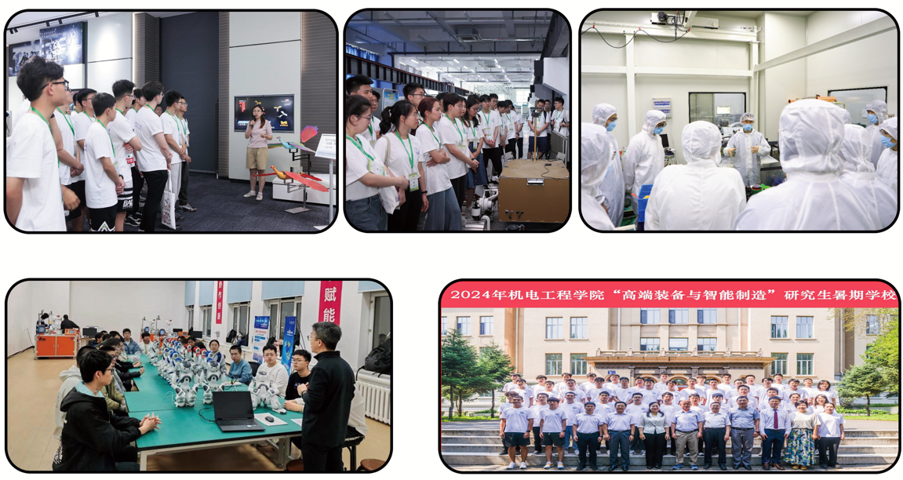
课堂教学：暑期学校将邀请院士、国家高层次人才等国内学术专家、国际知名学者，航空航天、机器人、高端装备等领域的企业专家和行业导师进行学术报告。
实践教学：学员将观摩机器人技术与系统国家重点实验室、宇航空间机构全国重点实验室、超精密加工国防科技工业先进技术研究应用中心、航空航天轴承技术及装备工信部重点实验室、黑龙江省超精密加工与特种加工重点实验室等科研基地，并与优秀研究生进行联谊交流。
研究生暑期学校开班时间：2026.07.13-2026.07.17
招生计划及对象：计划招生100人，面向校内外相关学科研究生及高年级优秀本科生。（将依据报名情况择优录取学员）
报名方式：本次研究生暑期学校面向全国招生，免注册费，名额有限。请意向报名的学员填写如下麦克表单报名，报名截止时间为2026年6月29日20点。
https://hitsmeyb.mike-x.com/Grvx5
联系电话：0451-86413811（于老师、姜老师）
联系地址：哈尔滨工业大学机械楼2035,机电工程学院研究生办公室

Harbin Institute of Technology Postgraduate Summer School on "High-end Equipment and Intelligent Manufacturing"
High-end equipment is the foundation of a strong country, providing important support for accelerating the development of new productive forces, implementing the strategy of building a strong manufacturing country, and constructing a modern industrial system. Intelligent manufacturing, as the key to upgrading the national manufacturing industry, plays an irreplaceable role in promoting technological innovation and industrial upgrading. High-end equipment is the carrier and product of intelligent manufacturing, reflecting the advantages of intelligent manufacturing in terms of technological content, value chain, and industrial chain.
The "High-end Equipment and Intelligent Manufacturing" Summer School, undertaken by the School of Mechatronics Engineering, closely integrates the strategic goal of "cultivating outstanding talents and building national major projects". Based on the research and development background of high-end equipment and the technological advantages of intelligent manufacturing in the School of Mechatronics Engineering, it provides an important platform for summer school students to expand their academic horizons, inspire academic ideas, and understand the characteristics of the discipline.
Academic Lectures: The summer school will invite academic experts such as academicians and national high-level talents, internationally renowned scholars, enterprise experts and industry mentors in the fields of aerospace, robotics, high-end equipment, etc. to give academic presentations.
Practical Activities: students will visit the State Key Laboratory and other laboratories, and communicate with excellent postgraduate students.
Program Dates: July 13-17, 2026
Enrollment Plan: The summer school is to enroll about 100 postgraduate students and outstanding undergraduate students.
Registration Method: Interested applicants should complete the online registration form below. https://hitsmeyb.mike-x.com/Grvx5
The registration deadline is 20:00 Beijing Time (UTC+8) on June 29, 2026.

Contact Phone Number: +86-451-86413811 (Ms. Yu、Ms. Jiang)

